03-Mar-22

**Experiment 6 - Predictive Parsing Table**

Dhawal Patil

RA1911003010575

CSE A2

**Experiment 6**

Aim:

To write a program to show predictive parsing table using Python language.

Algorithm:

1. Start the program
2. Initialize the required variables
3. Get the number of coordinates and productions from the user
4. Perform the following:

For (each production A → α in G)

For (each terminal a in FIRST(α))

Add A → α to M[A,a];

If (ε is in FIRST(α))

For (each symbol b in FOLLOW(A))

Add A → α to M[A,b]

1. Print the resulting stack
2. Print if the grammar is accepted or not
3. Exit the program

Code:

gram = {"E":["E+T","T"],"T":["T*F","F"],"F":["(E)","i"],"S":["CC"],"C":["eC","d"],}

def removeDirectLR(gramA, A):

temp,tempCr,tempInCr = gramA[A],[],[]

for i in temp:

if i[0] == A:

tempInCr.append(i[1:]+[A+"'"])

else:

tempCr.append(i+[A+"'"])

tempInCr.append(["e"])

gramA[A],gramA[A+"'"] = tempCr,tempInCr

return gramA

def checkForIndirect(gramA, a, ai):

if ai not in gramA:

return False

if a == ai:

return True

for i in gramA[ai]:

if i[0] == ai:

return False

if i[0] in gramA:

return checkForIndirect(gramA, a, i[0])

return False

def rep(gramA, A):

temp,newTemp = gramA[A],[]

for i in temp:

if checkForIndirect(gramA, A, i[0]):

t = []

for k in gramA[i[0]]:

t=[]

t+=k

t+=i[1:]

newTemp.append(t)

else:

newTemp.append(i)

gramA[A] = newTemp

return gramA

def rem(gram):

c,conv,gramA,revconv = 1,{},{},{}

for j in gram:

conv[j] = "A"+str(c)

gramA["A"+str(c)] = []

c+=1

for i in gram:

for j in gram[i]:

temp = []

for k in j:

if k in conv:

temp.append(conv[k])

else:

temp.append(k)

gramA[conv[i]].append(temp)

for i in range(c-1,0,-1):

ai = "A"+str(i)

for j in range(0,i):

aj = gramA[ai][0][0]

if ai!=aj :

if aj in gramA and checkForIndirect(gramA,ai,aj):

gramA = rep(gramA, ai)

for i in range(1,c):

ai = "A"+str(i)

for j in gramA[ai]:

if ai==j[0]:

gramA = removeDirectLR(gramA, ai)

break

op = {}

for i in gramA:

a = str(i)

for j in conv:

a = a.replace(conv[j],j)

revconv[i] = a

for i in gramA:

l = []

for j in gramA[i]:

k = []

for m in j:

if m in revconv:

k.append(m.replace(m,revconv[m]))

else:

k.append(m)

l.append(k)

op[revconv[i]] = l

return op

result,terminals = rem(gram),[]

for i in result:

for j in result[i]:

for k in j:

if k not in result:

terminals+=[k]

terminals = list(set(terminals))

def first(gram, term):

a = []

if term not in gram:

return [term]

for i in gram[term]:

if i[0] not in gram:

a.append(i[0])

elif i[0] in gram:

a += first(gram, i[0])

return a

firsts = {}

for i in result:

firsts[i] = first(result,i)

def follow(gram, term):

a = []

for rule in gram:

for i in gram[rule]:

if term in i:

temp,indx = i,i.index(term)

if indx+1!=len(i):

if i[-1] in firsts:

a+=firsts[i[-1]]

else:

a+=[i[-1]]

else:

a+=["e"]

if rule != term and "e" in a:

a+= follow(gram,rule)

return a

follows = {}

for i in result:

follows[i] = list(set(follow(result,i)))

if "e" in follows[i]:

follows[i].pop(follows[i].index("e"))

follows[i]+=["$"]

resMod = {}

for i in result:

l = []

for j in result[i]:

temp = ""

for k in j:

temp+=k

l.append(temp)

resMod[i] = l

tterm = list(terminals)

tterm.pop(tterm.index("e"))

tterm+=["d"]

pptable = {}

for i in result:

for j in tterm:

if j in firsts[i]:

pptable[(i,j)]=resMod[i[0]][0]

else:

pptable[(i,j)]=""

if "e" in firsts[i]:

for j in tterm:

if j in follows[i]:

pptable[(i,j)]="e"

pptable[("F","i")] = "i"

toprint = f'{"": <10}'

for i in tterm:

toprint+= f'|{i: <10}'

print(toprint)

for i in result:

toprint = f'{i: <10}'

for j in tterm:

if pptable[(i,j)]!="":

toprint+=f'|{i+"->"+pptable[(i,j)]: <10}'

else:

toprint+=f'|{pptable[(i,j)]: <10}'

print(f'{"-":-<76}')

print(toprint)

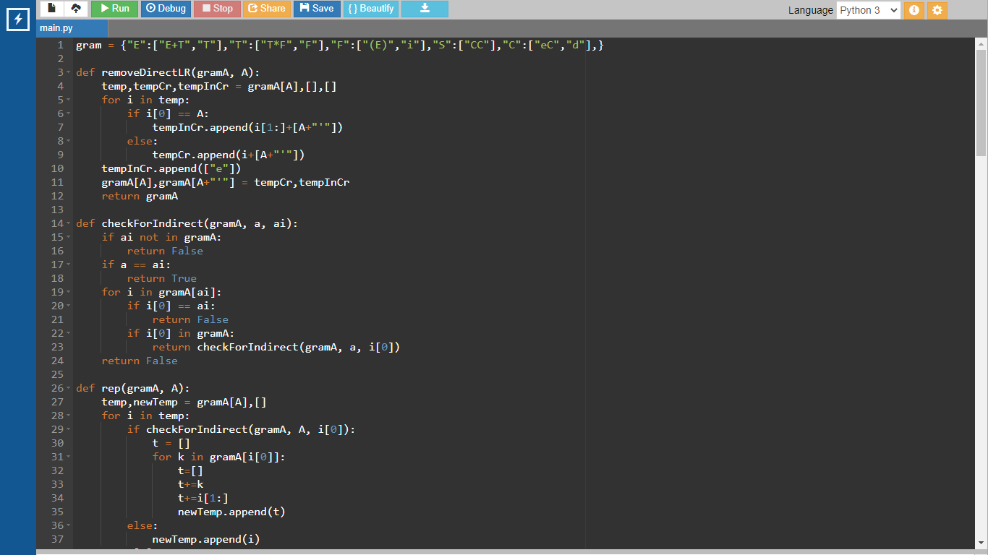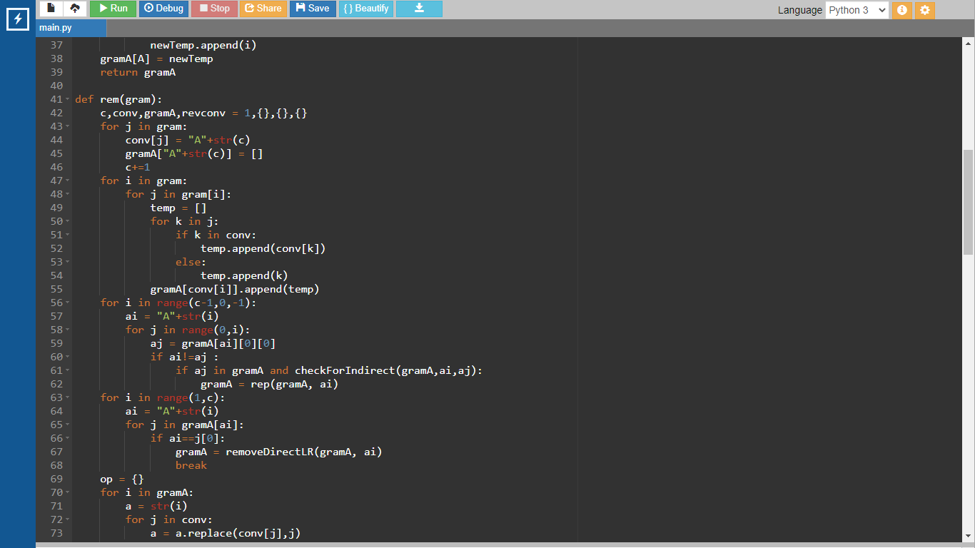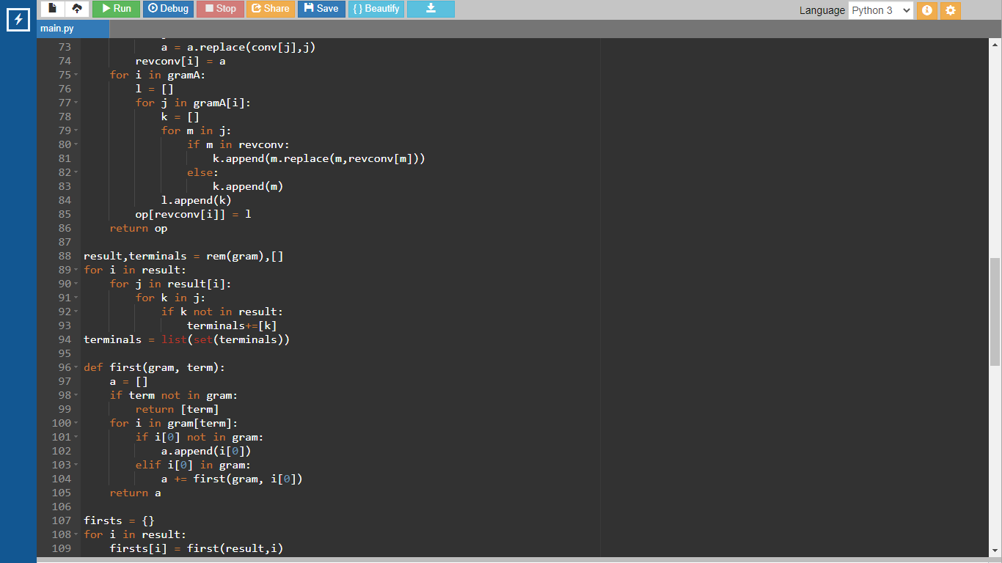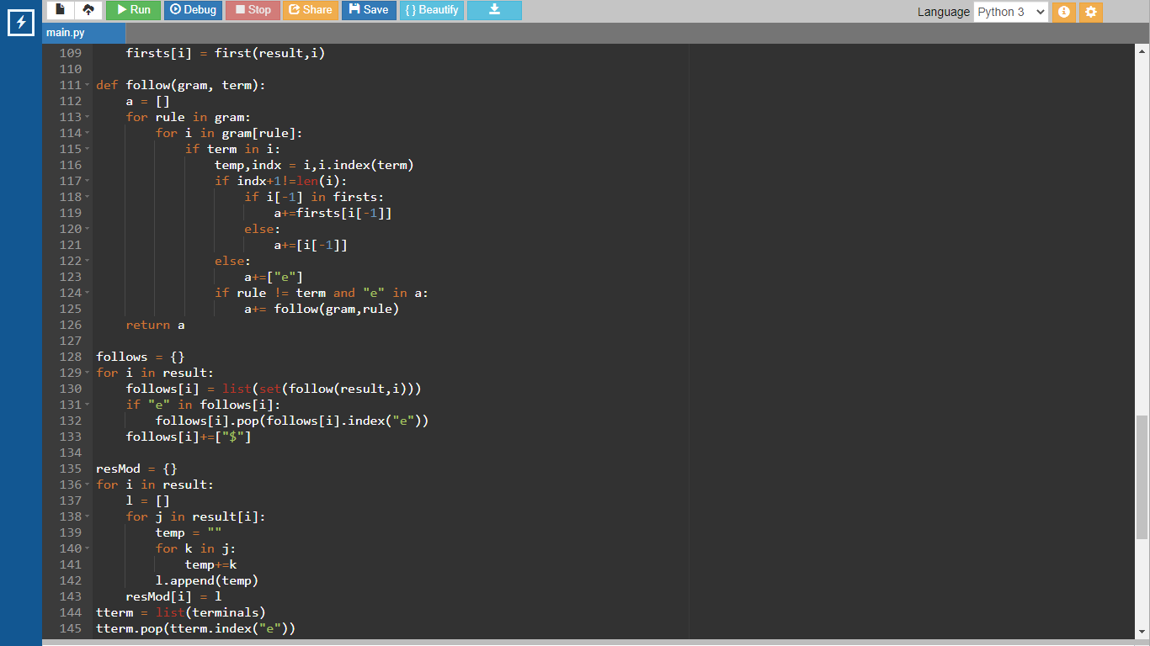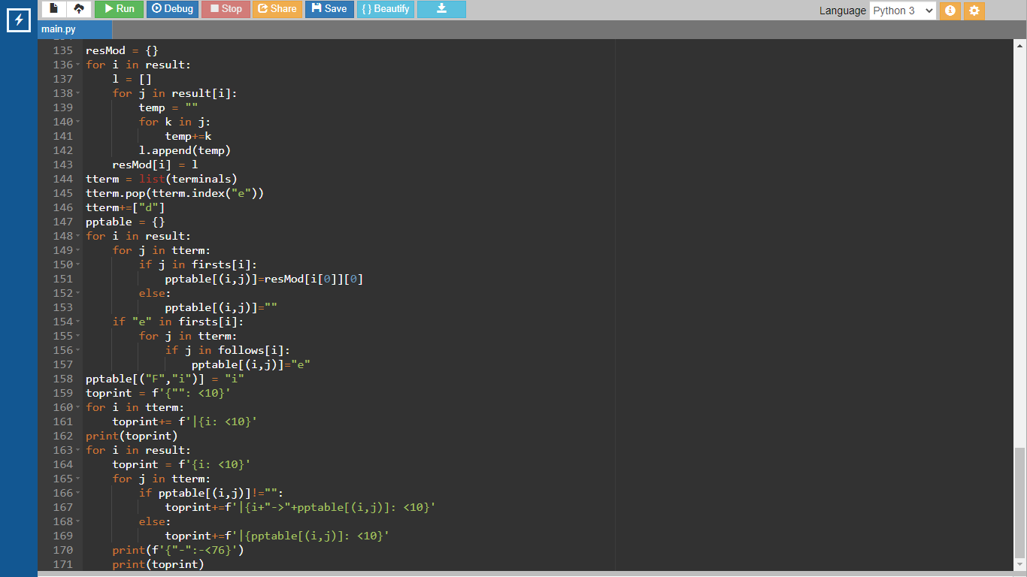

Output:

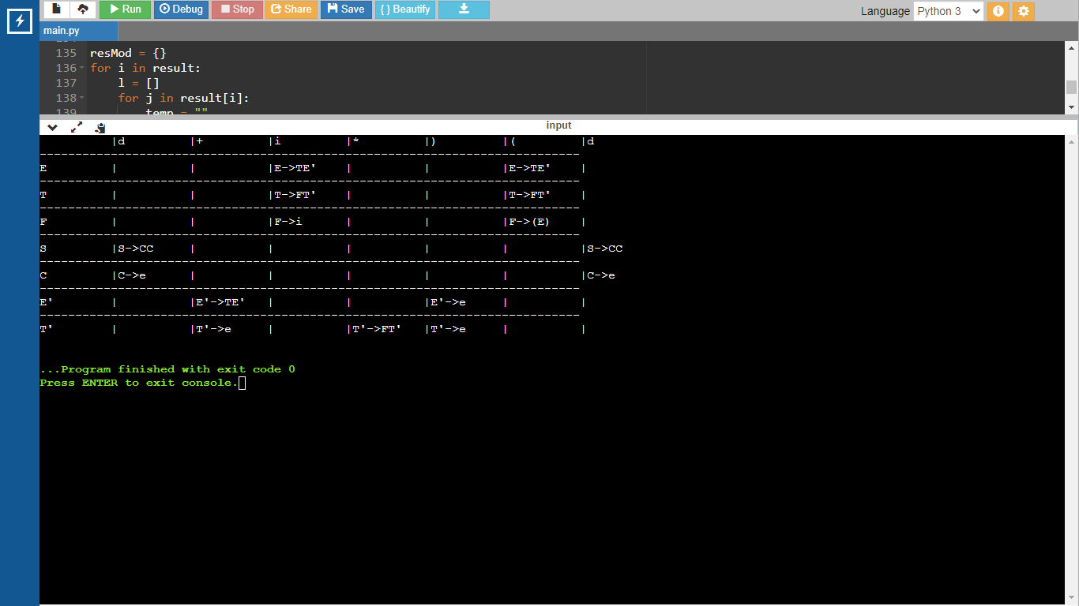

Result:

A program for Predictive parsing table was run successfully.